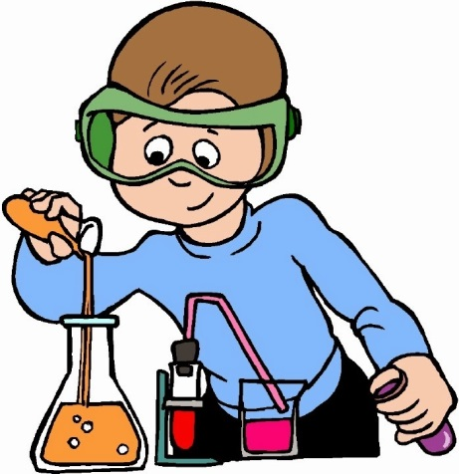
Formulas and Equations
Name _________________________________________ Hour _____
Write the number of atoms of each element in the compound. Extra credit: research the name of the compound, one is done for you
1. NO₂ Nitrogen ____ Oxygen ____ (_____Nitrogen Dioxide_____)
2. Al₂O₃ Aluminum ____ Oxygen ____ (______________________________)
3. C₂H₂ Carbon ____ Hydrogen ____ (______________________________)
4. Na₂CO₃ Sodium ____ Carbon ____ Oxygen ____ (___________________________________________)
5. C₆H₁₂O₆ Carbon ____ Hydrogen ____ Oxygen ____ (____________________________________)

Write the name and number of atoms of each element in the compound. One is done for you.
6. NH₃ Nitrogen 1, Hydrogen 3____________________________________________________________________
7. CO₂ _____________________________________________________________________________________________
8. NaOH _____________________________________________________________________________________________
9. Br₃KAu _____________________________________________________________________________________________
10. Hg₂Mn _____________________________________________________________________________________________
11. PbLi₂ ___________________________________________________________________________________________________________________________________________
Balance each equation by filling in the missing numbers. (use pencil...in case of a mistake)
12. ___Mg + O₂ ___MgO (magnesium oxide)
13. ___Na + Cl₂ ___NaCl (sodium chloride)
14. P₄ + ___O₂ ___P₂O₅ (phosphorus pentoxide)
15. ___C + ___H₂O C₆H₁₂O₆ (glucose)
Challenge:
16. S₈ ₊ ___O₂ ___SO₂ (sulfur dioxide)
17. ___CO₂ + ___H₂O C₆H₁₂O₆ + __O₂ (glucose and oxygen)
18. ___C₄H₁₀ + ___O₂ ___CO₂ + ___H₂O (carbon dioxide and water)
Balancing Chemical Equations…this is hard stuff…
1. Complete the table by listing the different elements in each molecular formula. Include the number of each atom. (Ex: Hydrogen 2, Einsteinium 5)
Molecular Formula | Composition (what is it made out of)
H₂SO₄
FeSO₄
Pb(NO₃)₂

2. Balance each of the following equations. Remember that for each element the number of atoms on either side of the equation must be equal. (hint: one question does not need to be balanced)
a. Al + O₂ Al₂O₃ ______________________________________________________________________________________
b. CO + H₂ CH₃OH _______________________________________________________________________________
c. AgNO₃ + NaCl AgCl + NaNO₃ _________________________________________________________________
d. Zn + HCl ZnCl₂ + H₂ __________________________________________________________________________
e. C₁₂H₂₂O₁₁ + C + H₂O ___________________________________________________________________________
f. Fe + O₂ Fe₃O₄ _______________________________________________________________________________

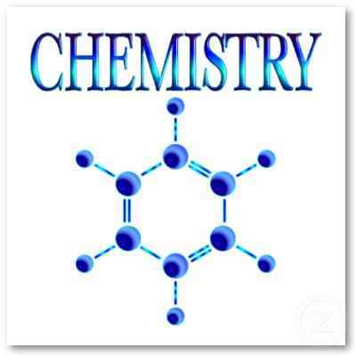
3. Fill in the missing chemical symbols or molecular formulas to balance the following equations.
a. 2 _________ + Cl₂ 2NaCl
b. _________ + F₂ 2HF
c. 4 _______ + O₂ 2Ag2O
d. Zn + H₂O ZnO + ________
e. SnO₂ + 2C 2CO + ________
f. 2NO + _______ 2NO₂
4. State in your own words the Law of Conservation of Mass
__________________________________________________________________________________________________________

