Convection currents in liquids
When a vessel containing a liquid is heated at the bottom a current of hot liquid moves upwards and its place is taken by a cold current moving downwards. Unlike conduction, where heat is passed on from one section of the substance to another, the heat is here actually carried from one place to another in the liquid by the movement of the liquid itself. This phenomenon is called convection. The same process occurs when a gas is heated.

Experiment to demonstrate convection currents in water
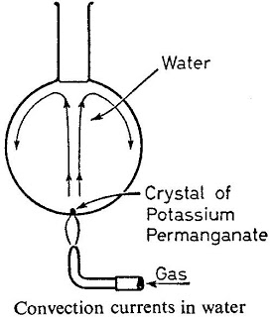
Convection currents in water
Convection currents in water may be shown by filling a large spherical flask with water and dropping a single large crystal of potassium permanganate ( KMnO₄) to the bottom of it through a length of glass tubing. A finger is placed over the end of the tube, which is then removed, together with the colored water it contains.
When the liquid is heated the density of the molecules DECREASES, which causes them to rise….just like smoke rises in the burning building. When the liquid reaches the top it comes in contact with cool room air, the temperature drops and DENSITY INCREASES AND THE WATER SINKS.
After a short time it circulates down the sides of the flask, showing that a convection current has been set up. The cycle will then repeat.

