Go to Zoomschool.com name _________________________________ hour ____
under SCIENCE/BIOLOGY click Earth,
Click Continental Drift
- How thick are the tectonic plates? _________________
- Look at the plate animation. How many million years ago were most of the plate on the bottom of the Earth? _____________
- Draw an arrow to the plate that you live on…..what is it’s name?
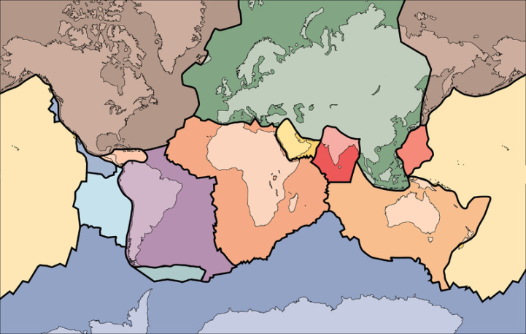

- Read about the theory of plate tectonics. Where do most volcanoes and earthquakes occur on the Earth and Why??? __________________________________________________________________
___________________________________________________________________________________________
- What are the three types of plate movement?
  - b. c.
- BRIEFLY Describe all three movements and include a simple drawing of them:

- When two plates separate in the ocean, describe what happens. __________________________
________________________________________________________________________________________
- Describe what happens when an oceanic plate and a continental plate collide.
_______________________________________________________________________________________
- How about two ocean plates? __________________________________________________________
- And two continental plates? ____________________________________________________________
- At lateral movement, What is the name of the plate boundary? ___________________________
- What scientist first proposed the theory of Continental Drift? _______________________

- How long ago were the continents connected? ____________________________

- Watch the animation of Pangaea splitting apart. Which major country of the world was an island 65 mya? _______________

- Go to Youtube.com, search: GeoDharmaYT. Watch the 1:14 minute video.
  - What happens to cooler rock in the mantle? ____________________________________
  - Describe what happened to the ocean plate? ________________________________________
____________________________________________________________________________________

- Now search ‘Himalayan Collision’, watch the :13 second animation.
  - Which county is colliding with Asia?______________________________________________

- Then search ‘Mountain Building Animation’, watch the :17 second animation.
  - When did India first touch Asia? _____________________________________
  - Does the continental crust (India) sink and melt? ___________________

- Search “how a seismograph works”. watch the 1:05 minute clip.
  - What modern device do most scientist use today? ____________________________________

- Search ‘Earth 100 million years from now’. Watch the 3:19 movie.
  - What are the two small plates directly south of the North American Plate? _____________________________, ________________________________
  - What will happen between Africa and Europe in 100 million years? _______________________________________________________________________

