Geology Final Review
- Name the four main layers of the planet and write what they are composed (made) of.

- Describe how we know these layers are there, if we have never drilled that deep.

- When an Earthquake wave travels through the earth, what does it look like? Draw on Earth above. Also What are the differences between P and S waves? Why do they bend as they go through the planet?

- Where do powerful Earthquakes and active Volcanoes occur in relation to a plate and it’s edge?

- Where does the magma come from that forms volcanoes at plate boundaries?

- Name the following boundaries:

- What do you call a divergent boundary in the ocean?
- Are ocean plates younger near the mid ocean ridge? Or farther away from the ridge? (use page 25 in your textbooks)
- Name the following collision, and draw the other two that you learned in the space below.
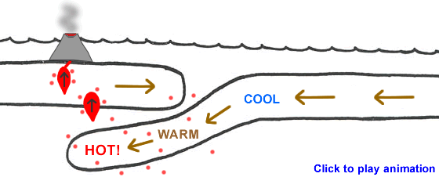
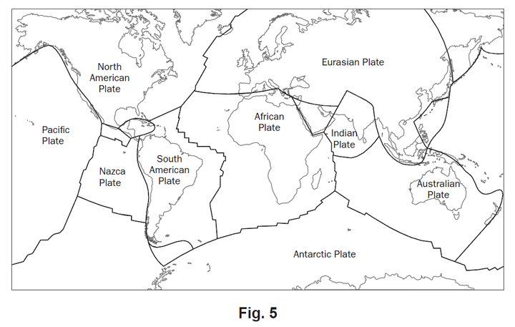
10. Put ten stars on the plate tectonic map (left) where you would guess a major earthquake or volcano could occur.

- In this meander, where is erosion and deposition occurring? Use dots to represent the sand bar.
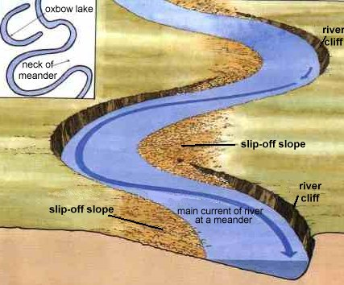
- In this picture, label where Erosion is happening and also where Deposition is occurring. and Explain why that is happening.

- What are constructive forces? Destructive forces?

- What is the lithosphere always doing? _______________, and _______________
- What is Weathering?
- What is Erosion?
- This river is flowing into the ocean and creating a delta, show how the size of sediments changes at the ocean gets deeper. (draw in the rocks)

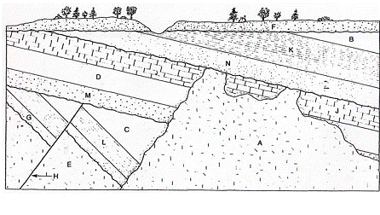

- Put these layers in order from OLDEST….to YOUNGEST
____, ____, ____, ____, ____, ____, ____,____, ____, ____, _____, _____, _____
- How do each of the following rocks form?
  - Sedimentary
  - Igneous
  - Metamorphic
- Why do some Igneous rocks have large Crystals and some no crystals?

- Describe what a physical and chemical change is.

- What are Pure Substances? Give some examples

- Decide if the following are chemical or physical changes:
  - Cracking a rock with a hammer
  - A firework exploding
  - Freezing water inside a rock
  - Acid rain “eating” a marble statue
  - A root breaking a rock in half
  - Dissolving sugar in water to make Kool-Aid.
  - Baking a cake

- In lab when you mixed the two liquids together and created the bright yellow precipitate what happened to the weight? _______________________________
  - Why did it stay the same? ______________________________________________________
  - What Law is this? ____________________________________________________________
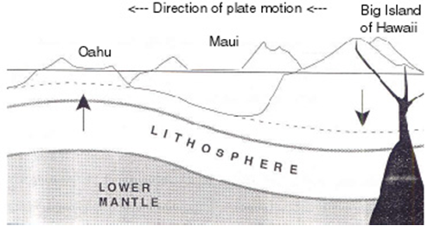
- Look at the Direction of plate motion. Observe where the hot spot is (Active Volcano). Then explain if Oahu, Maui, or the Big Island of Hawaii is the OLDEST??? Draw in the picture where the next Volcano will form.

HOT SPOT

Science with Sponge Bob….

Mr. Krabbs wants to make Bikini Bottoms a nicer place to live. He has created a new sauce that he
thinks will reduce the production of body gas associated with eating crabby patties from the Krusty
Krab. He recruits 100 customers with a history of gas problems. He has 50 of them (Group A) eat
crabby patties with the new sauce. The other 50 (Group B) eat crabby patties with sauce that looks just
like new sauce but is really just mixture of mayonnaise and food coloring. Both groups were told that
they were getting the sauce that would reduce gas production. Two hours after eating the crabby
patties, 30 customers in group A reported having fewer gas problems and 8 customers in group B
reported having fewer gas problems.

24. What are two constant/control variables?

25. What is the independent variable? (what changes)

26. What is the dependent variable? (what is measured)
27. What should Mr. Krabs’ conclusion be?

