Name:___________________________
Pangaea puzzle
Background:
In early 1915, the German scientist Alfred Wegener developed a theory that the continents once formed a giant super-continent that he called Pangaea. He speculated that Earth took this form about 245 million years ago. A few years after Wegener proposed his theory, South African geologist Alexander DuToit further theorized that Pangaea divided into two super continents 205 million years ago. DuToit called the northern super-continent Laurasia and the southern one Gondwanaland. Gondwanaland was comprised of the modern-day landmasses of South America, Antarctica, Australia, Africa, Madagascar, and India.
Wegener and DuToit used many kinds of evidence to advance their theories. They found similar fossil remains of plants and animals on different present-day continents. In this activity you will follow steps similar to those of Wegener and DuToit to show who fossils evidence supports the theory that one super-continent dived into two.

Materials:
Pencil Scissors Tape or a glue stick Colored pencils

Procedure:
- Use the information from the chart below and the map key code to mark the locations on the prehistoric landmasses where four types of fossils have been found.
- Once all of the fossils have been marked on the landmasses, cut out the continent shapes and try to piece them together as Gondwanaland. (Hint: Fossils of the same organism should be next to each other.)
- Tape or glue your finished version of Gondwanaland to the back of this page.

Analysis:
- What causes the plates/continents to move in the first place? (2 points)

- There was only continent: Pangaea…therefore there was only ONE ocean. Research what the name of this ocean was.

- Why wouldn’t the fossil of a salt water fish be good evidence for continental drift?

- Why is it important to know that the mesosaur lived in fresh water? Explain in detail.

- Remember the four layers of the planet? What are they and what are they made out of? (4 points)

Fossil Name | Description | Picture of Animal | Color for map | Present Day Location
Glossopteris | A fern | 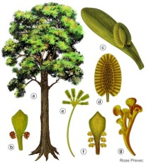 | green | - South of Perth, Australia  - Southern tip of India (near Madurai)  -Wilhelm II Coast, Antarctica  -Southern tip of Madagascar  -Oates Coast, Antarctica  -Southern Australia (near Melbourne)
Cynognathus | A land reptile | 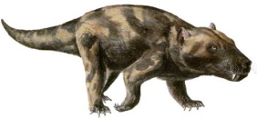 | orange | -Southern Argentina (near Bahia Blanca)  -Palmer Land, Antarctica  -Southwestern South Africa (near Cape Town)
Lystrosaurus | A land reptile | 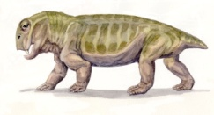 | red | -Western Australia (north of Perth)  -Madagascar (north of Antananarivo)  -Cenral India (between Bangalore and Hyderabad)  -Eastern Tanzania (south of Dal Es Salaam)
Mesosaurus | A freshwater reptile | 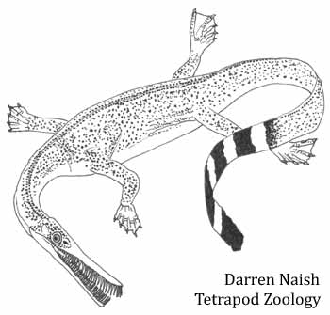 | blue | -Eastern Brazil (near Salvador)  -Cameroon, West Africa
Tape or glue your colored map here:

Prehistoric Landmasses

