(Page 2)
In your stream table: | Observations and Drawings (both)
Create an oxbow lake
Dam the stream, and then let it break and create a large delta…
Make a V Shaped valley and an Alluvial fan

- Predict what happens to the shape and size of rocks the longer they are exposed to water.

- Where are there Constructive forces in your stream table:

- Where are there Destructive forces in your stream table:

- What landform is forming at the bottom of your stream table? (check notes)

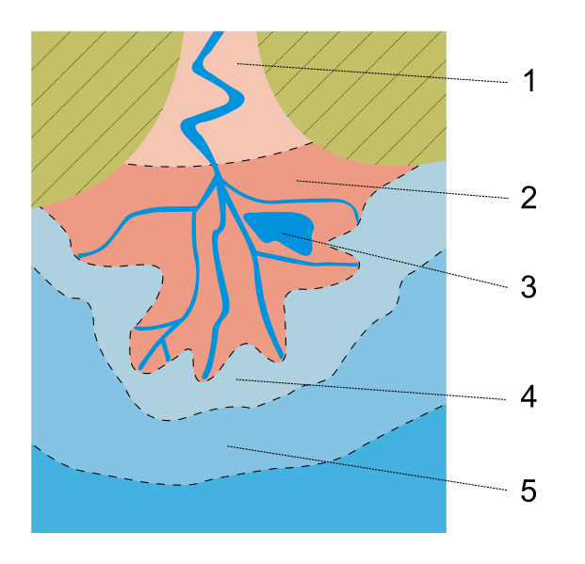
- In the following delta diagram at what number would you find the smallest pieces of rock? ____ where would the largest most likely be? _____
(this is a birds-eye-view diagram, and the water is flowing south into the ocean)

Add rocks to this drawing of a river entering an ocean, showing how the size changes as you go farther out.

Stream Table Experiment Name__________________________ Hour __

Question: ____________________________________________________
Hypothesis: ___________________________________________________________________

Draw your stream below. Write E’s where erosion is occurring and write D’s where deposition is occurring.
In this meander below, show where the sandbar is building up by using little dots to represent sand.

Conclusion: (explain where erosion is happening, and deposition, and WHY!!!) (5 points)

_________________________________________________________________________
_________________________________________________________________________
__________________________________________________________________________
__________________________________________________________________________

