What in the Volcano is that??????
□ 1. What is the name of your volcano (provide a picture of it) and in what part of the world is it found (provide a map that shows what part of the world it is found in)?
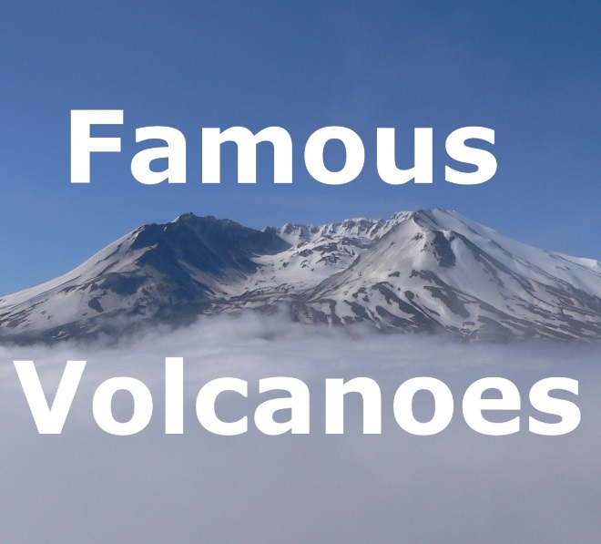
□ 2. What type of volcano is it? (use your textbook for help, pg 100)

□ 3. What is the volcanoes current elevation?

□ 4. Is the volcano active, dormant, or extinct? And explain what each of them
mean. (textbook is good resource)

□ 5. What are the 2 main types of magma and how do they differ from each other (this info. can be found in your textbook, page 90) Also, include several pictures of each one. (a short video would be awesome to. JS)

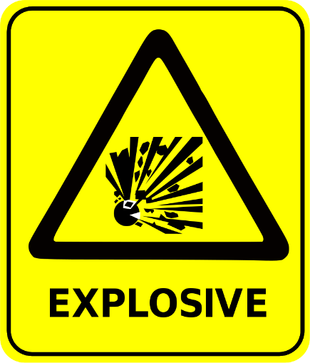
□ 6. Does the volcano usually have “explosive” eruptions or “quiet” eruptions (or both violent and quiet) (include pictures)? What factors determine whether a volcano has a “violent” or “quiet” eruption? (again…textbook 94…you get the picture?)
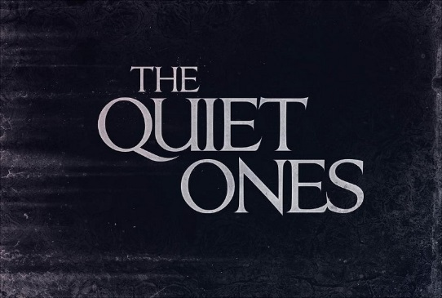
VS.

□7. How frequently does it erupt or has it erupted throughout history (if necessary, provide an approximation)?

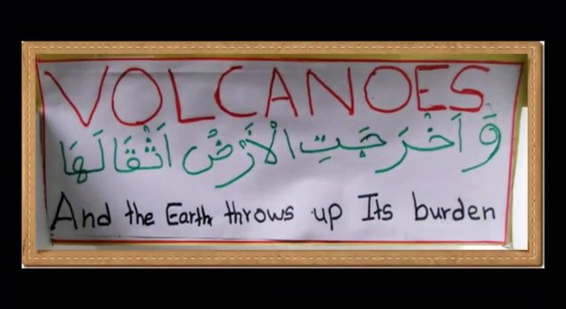
□ 8. How has your volcano affected the lives of people (and/or the general environment) either living nearby the volcano or in other parts of the world?

□ 9. Does this volcano form from a hot spot or subduction?

Make a Presentation in Hastings Apps, cite sources and when finished Share with me: rcrownhart@hastingsapps.org
(20 point project)

